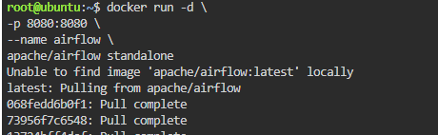

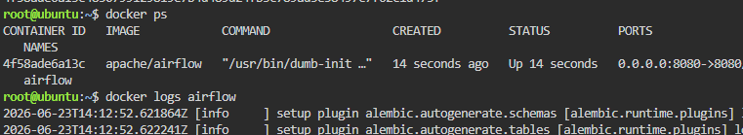

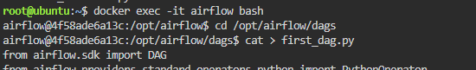

cat > first_dag.py
from airflow.sdk import DAG
from airflow.providers.standard.operators.python import PythonOperator
from datetime import datetime
def task1_function():
print("Task 1 Started")
def task2_function():
print("Task 2 Running")
def task3_function():
print("Task 3 Completed")

with DAG(
dag_id="first_training_dag",
start_date=datetime(2025, 1, 1),
schedule="@daily",
catchup=False,
tags=["training"]
) as dag:
task1 = PythonOperator(
task_id="task1",
python_callable=task1_function
)
task2 = PythonOperator(
task_id="task2",
python_callable=task2_function
)
task3 = PythonOperator(
task_id="task3",
python_callable=task3_function
)
task1 >> task2 >> task3

